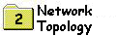
NETWORK TOPOLOGY
Topology refers to the way in which the network of computers is connected. Each topology is suited to specific tasks and has its own advantages and disadvantages.
The choice of topology is dependent upon
- type and number of equipment being used
- planned applications and rate of data transfers
- required response times
- cost
There are FOUR major competing topologies
- Bus
- Ring
- Star
- FDDI
Most networking software support all topologies.

Bus Topology
- all workstations connect to the same cable segment
- commonly used for implementing Ethernet at 10mbps
- the cable is terminated at each end
- wiring is normally done point to point
- a faulty cable or workstation will take the entire LAN down
- two wire, generally implemented using coaxial cable during the 1980's
The bus cable carries the transmitted message along the cable. As the message arrives at each workstation, the workstation computer checks the destination address contained in the message to see if it matches it's own. If the address does not match, the workstation does nothing more.
If the workstation address matches that contained in the message, the workstation processes the message. The message is transmitted along the cable and is visible to all computers connected to that cable.
There are THREE common wiring implementations for bus networks
- 10Base2 (thin-net, CheaperNet) 50-ohm cable using BNC T connectors, cards provide transceiver
- 10Base5 (ThickNet) 50-ohm cable using 15-pin AUI D-type connectors and external transceivers
- 10BaseT (UTP) UTP cable using RJ45 connectors and a wiring centre

Physical Implementation Of A Bus Network
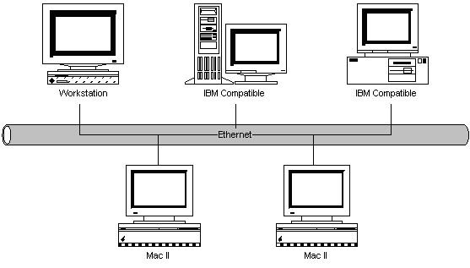
The above diagram shows a number of computers connected to a Bus cable, in this case, implemented as Thin Ethernet. Each computer has a network card installed, which directly attaches to the network bus cable via a T-Connector.
It is becoming common to use 10BaseT (UTP) for implementing Ethernet LANS. Each workstation is wired in star fashion back to a concentrator wiring centre (hub). The hub is a multi-port device supporting up to about 32 ports. One of these ports is connected to a server, or the output of the hub can be connected to other hubs.

Ethernet 802.3: Carrier Sense Multiple Access with Collision Detection (CSMA/CD)
This protocol is commonly used in bus (Ethernet) implementations.
Multiple access refers to the fact that in bus systems, each station has access to the common cable.
Carrier sense refers to the fact that each station listens to see if no other station is transmitting before sending data.
Collision detection refers to the principle of listening to see if other stations are transmitting whilst we are transmitting.
In bus systems, all stations have access to the same cable medium. It is therefore possible that a station may already be transmitting when another station wants to transmit. Rule 1 is that a station must listen to determine if another station is transmitting before initiating a transmission. If the network is busy, then the station must back off and wait a random interval before trying again.
Rule 2 is that a station which is transmitting must monitor the network to see if another station has begun transmission. This is a collision, and if this occurs, both stations must back off and retry after a random time interval. As it takes a finite time for signals to travel down the cable, it is possible for more than one station to think that the network is free and both grab it at the same time.
CSMA/CD models what happens in the real world. People involved in group conversation tend to obey much the same behavior.

Physical Bus Cable Limits
10Base2 THIN ETHERNET NETWORK LAYOUT
Limitations
- maximum number of trunk segments = 5
- maximum trunk segment length = 607 feet (185 meters)
- maximum network trunk cable = 3035 feet (925 meters)
- maximum number of stations on a trunk segment = 30
- minimum distance between T connectors = 1.5 feet (0.5 meters)
Rules
- each end of the trunk segment is terminated in 50-ohms
- one of the terminators is grounded
- connector splices are kept to a minimum
Cabling
- BNC-T type connectors
- RG58-AU 50-ohm cable, 0.2"
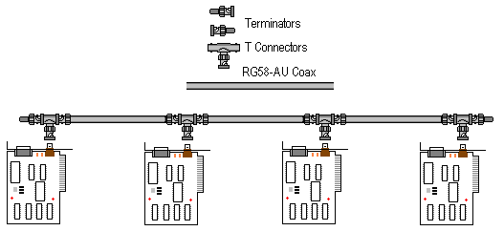

10Base5 THICK ETHERNET NETWORK LAYOUT
Limitations
- maximum number of trunk segments = 5
- maximum trunk segment length = 1640 feet (500 meters)
- maximum network trunk cable = 8200 feet (2500 meters)
- maximum number of stations on a trunk segment = 100
- minimum distance between transceivers = 8 feet (2.5 meters)
- maximum transceiver cable length = 165 feet (50 meters)
Rules
- each end of the trunk segment is terminated in 50-ohm
- one of the terminators is grounded
- connector splices are kept to a minimum
Cabling
- Transceivers 802.3
- 50-ohm cable RG-11
- Male DIX connector
Wiring of the DIX Connector
Pin | Ethernet | IEEE 802.3
1 | Shield | Control-in | Shield
2 | Collision presence+ | Control-in | A
3 | Transmit+ | Data-out | A
4 | Reserved | Data-in | Shield
5 | Receive+ | Data-in | A
6 | Power return | Voltage | common
7 | Reserved | Control-out | A
8 | Reserved | Control-out | Shield
9 | Collision presence- | Control-in | B
10 | Transmit- | Data-out | B
11 | Reserved | Data-out | Shield
12 | Receive- | Data-in | B
13 | Power | Voltage
14 | Reserved | Voltage | Shield
15 | Reserved | Control-out | B
Shell | --- | Protective | Ground
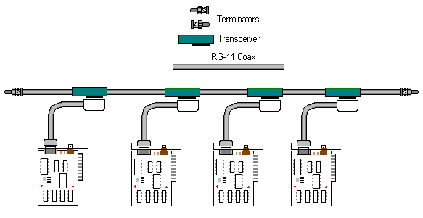

10BaseT UTP NETWORK LAYOUT
Limitations
- maximum segment length of 100 Meters
- Hub to Hub or repeater to repeater links limited to 100 Meters
Rules
- star topology
- 4 repeater/5 segment rule of 10Base5 is retained
- only two nodes per segment are allowed
Cabling
- RJ-45 Connectors
- Category 3 UTP minimum, preferably Category 5
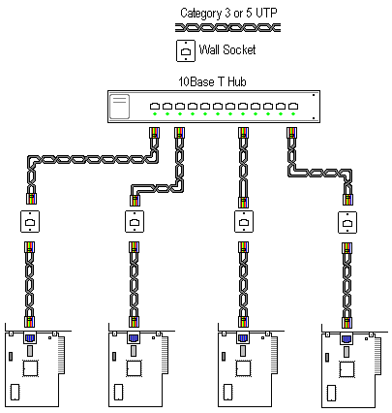

Bus Network Topology Summary
Advantages | Disadvantages
Easy to implement | Limits on cable length and Workstation numbers
Low Cost | Difficult to isolate network faults
 | A cable fault affects all workstations
 | As the number of workstations increase, the speed of the network slows down

